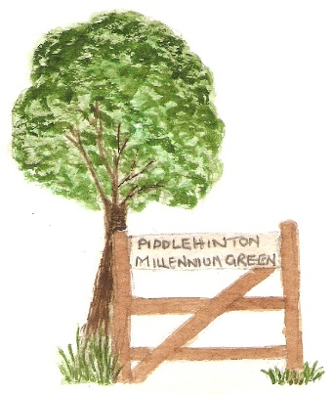
Be a Friend of the Green
Name (Family):

Email:

Amount £……………

Tick payment method:

Bank transfer [ ], Cash [ ], Cheque [ ], Scanned QR code [ ]

For bank transfer: Account 51391593: Sort code 40-19-21,
ref: your name
For cheques: make payable to Piddlehinton Millennium Green Trust
Gift Aid [ ] tick if appropriate and complete section below.

Charity Gift Aid Declaration – single donation

Boost your donation by 25p of Gift Aid for every £1 you donate
Gift Aid is reclaimed by the charity from the tax you pay for the current tax year Your address is needed to identify you as a current UK taxpayer

To Gift Aid your donation you must tick the box [ ]
I want to Gift Aid my donation of £……………
to Piddlehinton Millennium Green Trust, Registered charity, #1074956

I am a UK taxpayer and understand that if I pay less Income Tax and/or Capital Gains Tax in the current tax year than the amount of Gift Aid claimed on all my donations it is my responsibility to pay any difference.

My Details

Title First name or initial(s) Surname

Full Home address

Postcode Date

Please notify the charity if you: [ ] want to cancel this declaration, [ ] change your name or home address [ ] no longer pay sufficient tax on your income and/or capital gains. If you pay Income Tax at the higher or additional rate and want to receive the additional tax relief due to you, you must include all your Gift Aid donations on your Self-Assessment tax return or ask HM Revenue and Customs to adjust your tax code

Piddlehinton Millennium Green Trust will not disclose personal details

